# **TASKS**

**Objective Questions**:

1. What is the total no. of tables present in the data?

**Ans:**(1)-Raw Data & (2)-Country Discription

1. What is the total no. of attributes present in the data?

**Ans: 33 (27 -Raw data)(6-country description)**

1. How many categorical columns are there in the data? [Search about categorical and continuous data, and try to answer this question]

**Ans: 6 where I can use formulas like ( Inr currency rate, Symbol,Combined money with symbol, Real cost, Year,Month )**

1. The data consists of some inconsistent and missing values so ensure that the data used for further analysis is cleaned.

**Ans: Cuisines has 9 missing values i have enter the most matched cuisines in it Also there is an inconsistency in average cost of two people column I.e its never be zero I will delete the entire row who has 0 value then their will be 9534 rows available.**

1. Using the LookUp functions, fill up the countries in the original data using the country code.

**Ans: =** By using VLOOKUP I fill up the countries column in the original data using the country code.

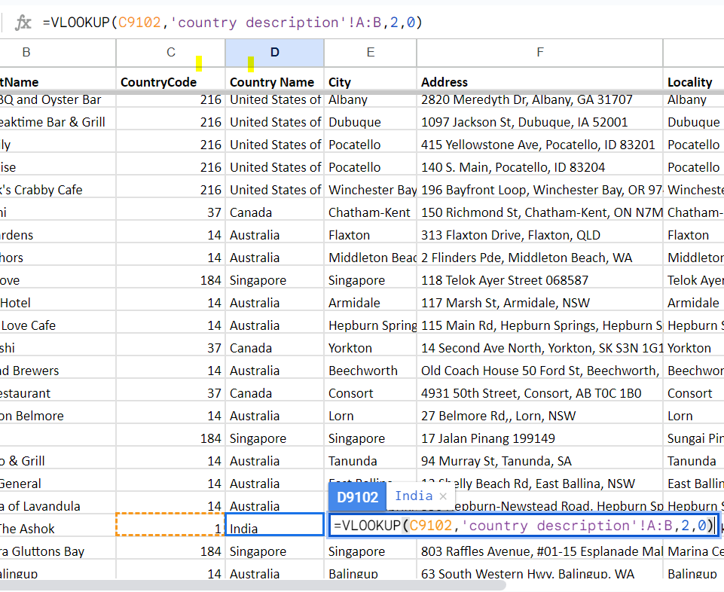

1. Create a table to represent the number of restaurants opened in each country.

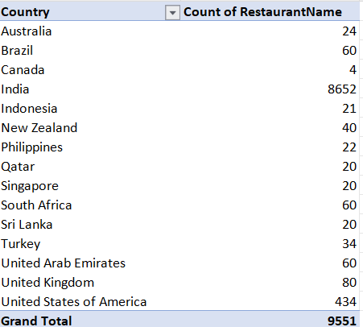

1. Also, the management wants to look at the number of restaurants opened each year, so provide them with something here.

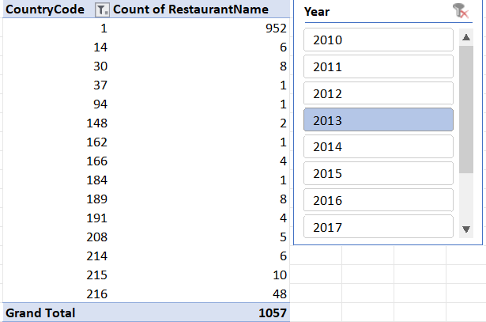

1. What is the total number of restaurants in India in the price range of 4?

**Ans:** 388

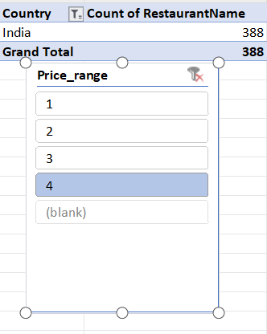

1. What is the average number of voters for the restaurants in each country according to the data?

**Ans:**

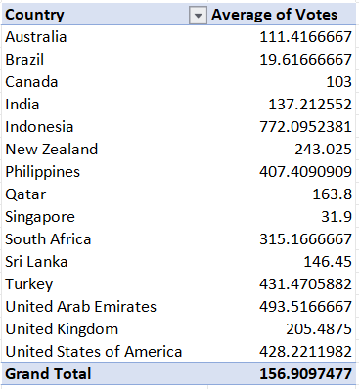

1. Calculate the average rating for all the restaurants that have price_range < 4 and provide online delivery. Use only the “IF” function, Logical Operators, and Aggregation functions to solve this problem. **[Note: Don’t use Conditional aggregation in this question.]**

**Ans: Making new column ie average rating with the given condition**

**=IF(AND(M2<4,K2="Yes"),P2,"")**

**Where M is Price range column**

**K is has online delivery available column**

**And P is Rating of the data !!**

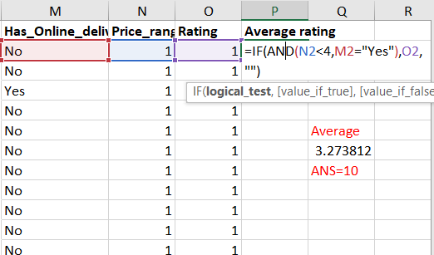

**Result :: 3.27381151**

1. Using Conditional formatting highlight the rows of restaurants that are located in the countries or cities that you’ve suggested to the management for opening new restaurants.

**Ans:** HOME -> Conditional formatting -> New Rule -> Use a formula to determine which cell to format

=AND($M2=$M$3,$P2=3,$S2>2.8,OR($R2>250,$R2<500)

In this I select entire row whose rating> 2.8 and price range in between 250 and 500 by applying logical operation with if function. By generating formula in conditional formatting.

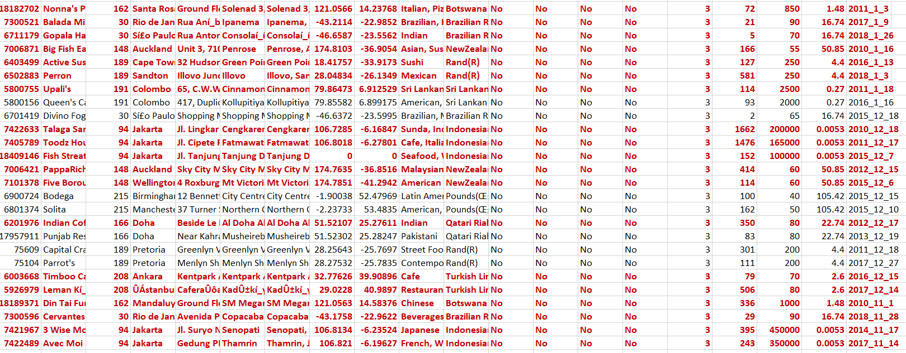

1. Create a new customized price column that consists of the abbreviation/symbol of the currency along with the Average_cost_for_two value. [Use string operations to do this task]

**Ans: Customized price column present in Raw data of excel sheet.** 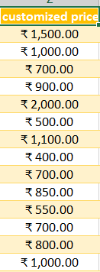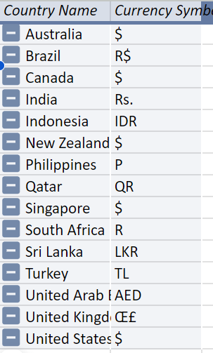

1. How can you create an array formula in Excel or Google Sheets to count the number of restaurants listed that do not offer online delivery, are in the lowest price range, and have an average cost for two people less than or equal to 250 Indian Rupees?

**Ans: After Applying Array formula i.e..**

**See excel file home – objective- column Q we get,**

**{=SUM((M:M = $M$2)*(P:P= $P$2)*(W:W <=250))}**

**Result: 1720**

**Where M is Has online delivery column &**

**P is price range column &**

**At last W is an INR average cost of 2 column.**

**Subjective Question:**

1. **Suggest a few countries where the team can open newer restaurants with lesser competition. Which visualization/technique will you use here to justify the suggestions?**

**Ans:** Using pivot table to aggregate the lesser competition to the team to open new restaurant by votes and rating in less competative country.display the distribution with piechart using slicer allowing for compairing different countries.

**Which would be look like this**: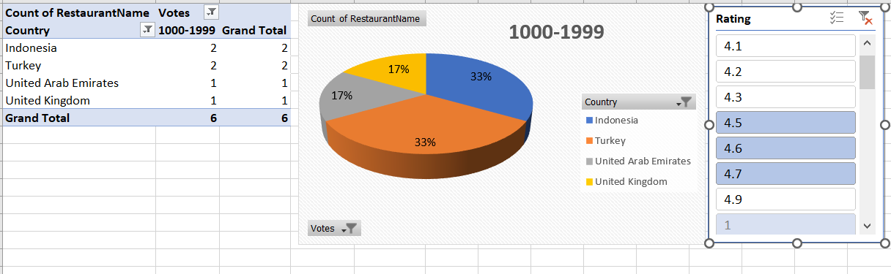

* Insights:
* Rating preferences: This indicates which country has less restaurant but good food quality as well as better infrastructure by customer point of view.
* Votes: This will help to decide the better restaurant of that area by customer going prospectus.
* Market Pricing & Positioning: This plays an major role where the restaurant is going to be open how far from the market place what was their average 2 person cost etc.
* Population Density: The per capita income of the city plays an major role to run, A profitable business Also the population of that area if it is an tourist place then it boom for the newer restaurants.
* Advertisement : This is an important feature which can decide the future of restaurant business in this higher competitive world.

**2.Come up with the names of States and cities in the suggested countries suitable for opening restaurants**.

**Ans:**

* Guidelines: Use a pivot table to aggregate the number of Restaurants by Online Delivery outcome in each country. Display the distribution with a Donut chart, allowing for comparison across different States of the country.

**Which could look like this:**

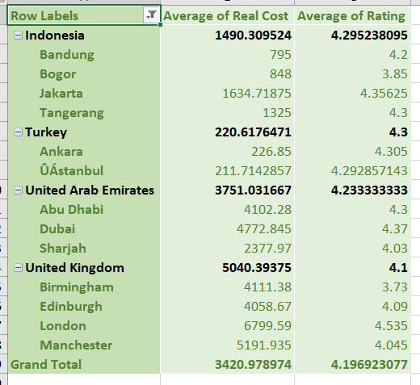

Approach:

* Has online delivery Preferences: Indicates which countries have more Delivery option available in either the low or high average prices in INR.
* Market Positioning: Helps in understanding how restaurants are positioned in terms of pricing in different cities.

Recommendations:

* Market Strategy: In countries with a higher number of restaurants in the high price range, consider premium offerings. In contrast, focus on affordability in countries with more low-priced Restaurants.
* Pricing Flexibility: Be adaptable in pricing strategies to cater to the prevalent market conditions in each country.

**3.According to the countries you suggested, what is the current quality regarding ratings for restaurants that are open there.**

**Ans:** Guidelines: With the help of visualization tool we can concure out with this

Problem by pivoting country in a row and Average of rating in values of the

Field list then inserting pivot chart with the help of pivot table As u see below.

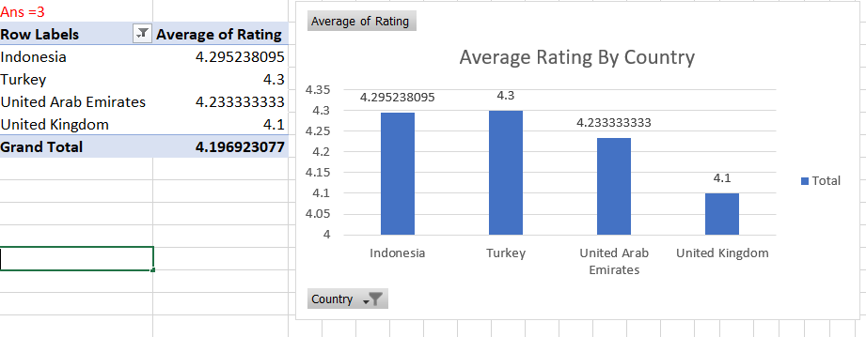

Approach : To assess current quality based on ratings, I calculated the average rating for restaurants in each country. According to the summary, Indonesia has avg.rating 4.29,Turkey has 4.3, UAE has 4.23 and UK has 4.1

**4. Also, what is the current expenditure on food in the suggested countries, so we can keep our financial expenditure in control?**

**Ans:**

As question asked the current expenditure on food in the suggested

Countries is obtained by select country on a row and taking INR

Converted money in average form we get the output as diagram.

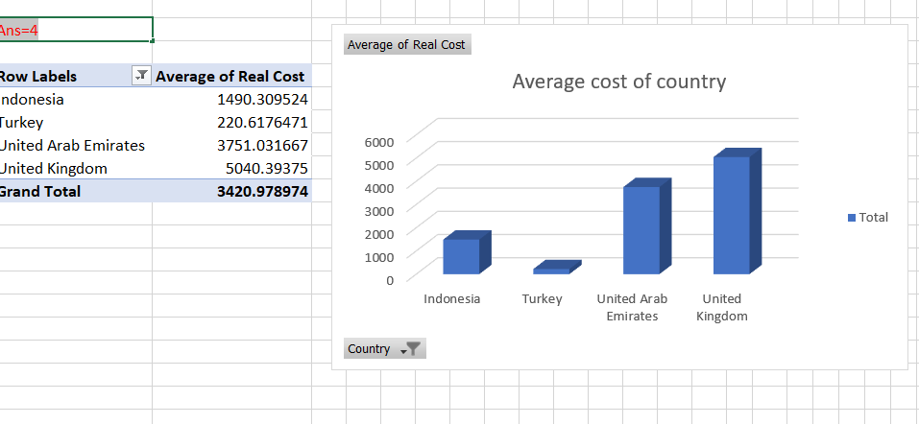

**5. Come up with the names of restaurants from the recommended states that are our biggest competitors and also those that are rated in the lower brackets, i.e. 1-2 or 2-3.**

**Ans:**

According to question I am try to indicate the state with group by rating & votes

as I initially created separate charts for each country because the voting ranges differed significantly between them.The number of votes by each restaurant name, filtering those with set a minimum threshold: 154 votes for UAE, 26 votes for UK, an. The resulting list of restaurants was then organized into groups based on their rating ranges. Essentially, it involved counting votes for each restaurant and categorizing them by their rating level, in their particular countryand considering only those with a significant number of votes.

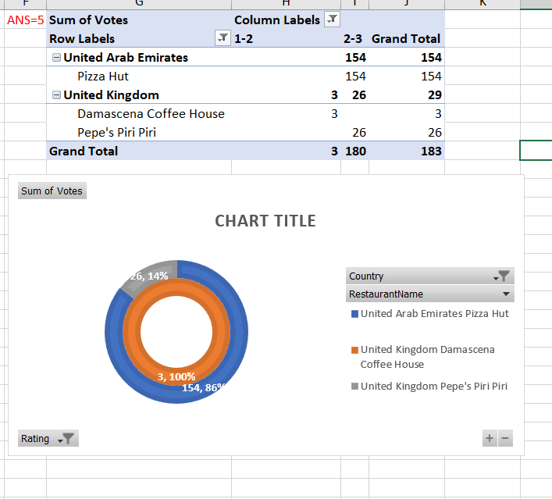

1. **Which cuisines should we focus on in the newer restaurants to get better feedback? Does the choice of cuisines affect the restaurant ratings?**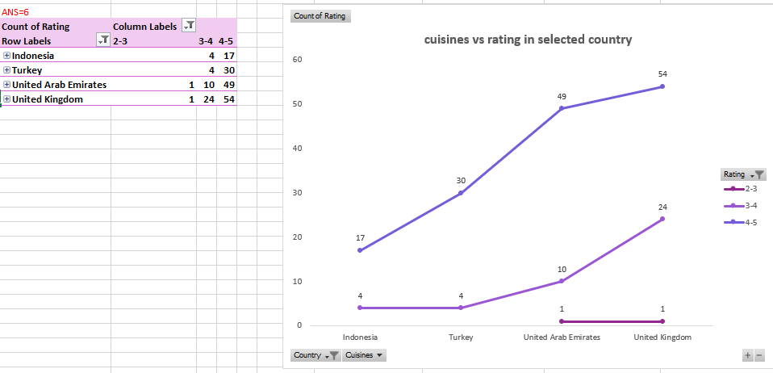

**Yes, Rating will effect the choice of cuisines as we see in graph that those who have higher the rating are chosen as better cuisines than others also their no. of votes is high as shown in diagram 2 .**

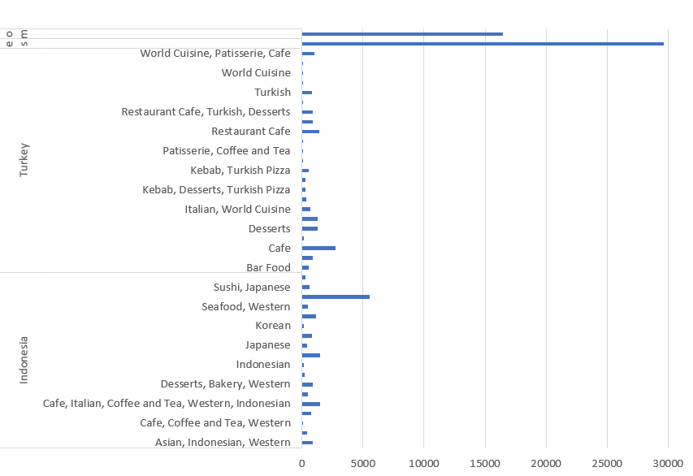

1. **According to our current data, should we go for online delivery and table booking? Does that affect the customer’s ratings.**

**Ans:** Yes, it appears that the presence of online delivery services may positively influence customer ratings, as indicated by the higher average ratings observed for restaurants offering this facility compared to those without it.from 12% ->26%

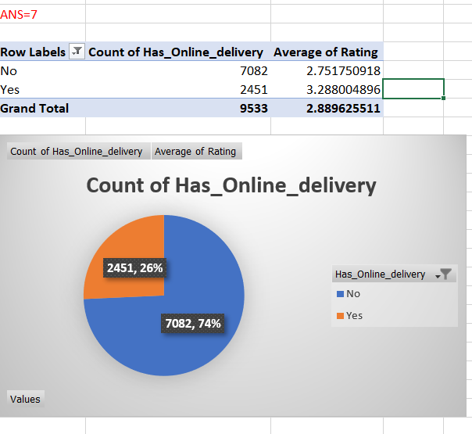

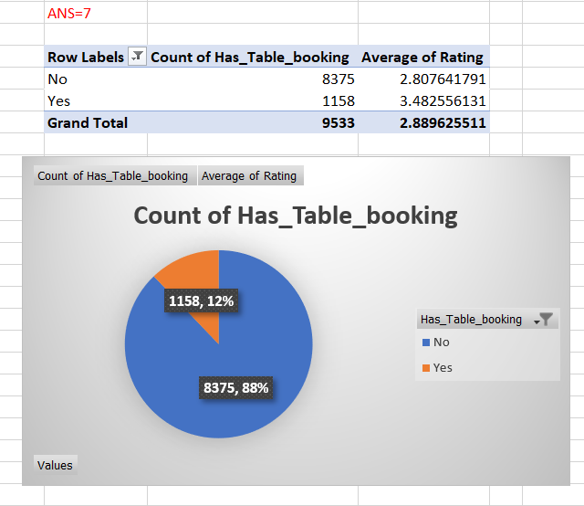

1. **Should the team keep the rate of cuisines higher? Will that affect the feedback? According to our data are the rates of cuisines and ratings, correlated?**

**ANS:**

**There is a weak correlation between price of cuisines and customers rating. So based on this correlation factor alone, it may not be advisable for the team to focus on keeping higher rates of cuisines to get better ratings.**

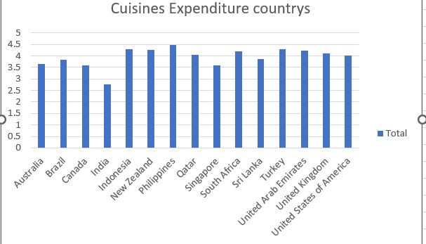

1. **What is the distribution of the number of restaurants of different price ranges in all the countries?**

**ANS: Using a pivot taking price range as column and count of restaurant name in values, this distribution of the number of different price ranges in all the countries is found**

Countries like Qatar, Singapore, and South Africa seem to have a larger customer base favoring restaurants in a higher price- range. This suggests a potential market for upscale or premium dining establishments in these locations.

* Canada, Australia, and the United States appear to have a higher concentration of customers frequenting restaurants in the mid-range price bracket (represented by number 2). This indicates a potential demand for casual dining or restaurants offering good value for money
* India stands out as a country where customers seem to gravitate more towards budget-friendly restaurants (represented by number 1). This suggests a market where affordability might be a key consideration for diners.

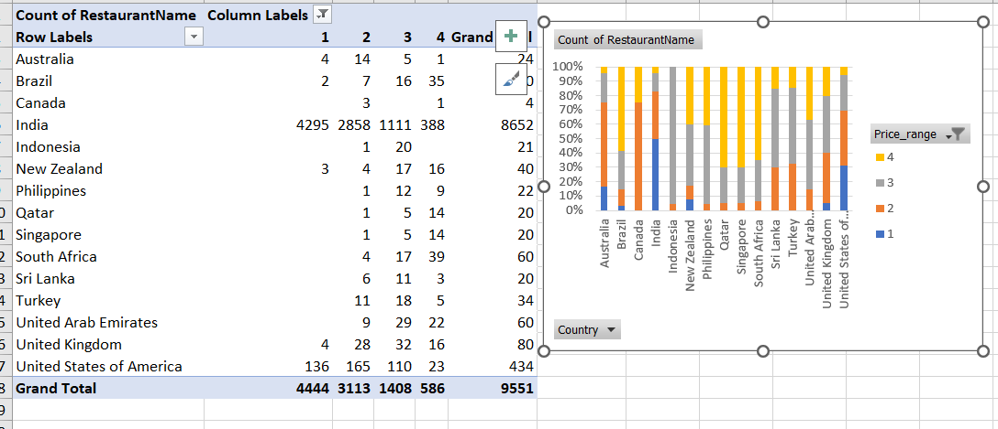

1. **Explain your approach in brief for suggesting countries/cities in order to open new restaurants, if the objective and subjective questions would have not been given to assist you. [you have to give bullet pointers in order to answer this question]**

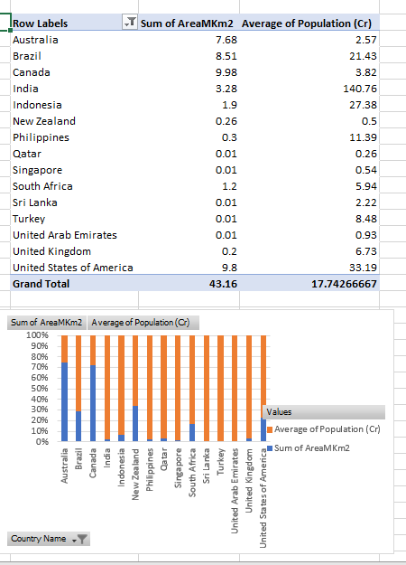

**ANS:**

My Pov is that we should see the Average of population of each country as well as tourism of that city matters allot information could provide valuable insights**,**

* Cloud kitchen facility available
* Easy and friendly of online delivery culture
* Google rating is affect allot
* Availability of most selling and buying cuisines
* Table booking system is available with no extra charge
* Average of 2 people is in between 500 to 2500.